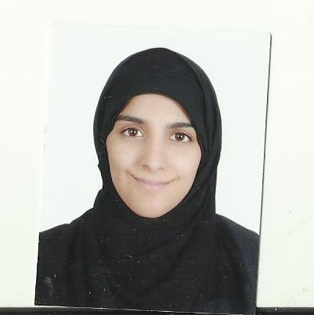cv

**Personal data:**

Name: Fatima Abdul Razzaq Ibrahim Abdullah

Eag:22 years old

Date of birth: 26/2/1996

View Profile: 960207236

Nationality: Bahraini

Gender: Female

Religion: Muslim

Martial status: married

Place of residence: Hous1973:Complex:1216 Road:1634

Phone number: 33197832

Email:fatoooom262@gmail.com

Qualifications:

* Graduated Public secondary department of literature(graduated in 2014)

• Certificate in Voluntary Work (2014 to 2016)

* Got a Certificate in Short Story Writing (2015)

• Received a certificate in general skills by the Ministry of Labor at the Mashreq Institute (2016)

**Practical experiences :**

I worked in accounting and reception restaurants and responded to customers

**Identities and Interests:**

- reading and writing

- listening to quiet music

**Languages:**

_ Arabic 100%

_ English 50%